
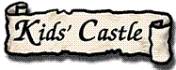

Name ……………………………………

Date ……………………………………..

Instructions

Write a set of clear instructions
Look at the Kids’ Castle web page: http://www.kidsonthenet.com/castle. Go to Lord Sherwood’s Rooms.
Imagine that you are Lady Sherwood. You want to give a big feast in honour of Lord Sherwood’s birthday. Your Steward, Sir Hugo, will do all the hard work for you, but you need to tell him exactly what needs doing. Your job is to write him some very clear instructions.
Check out the Great Hall and the Kitchens in Kids’ Castle to help you with your ideas.

What sort of food do you want at the feast?

Who will prepare the food?

What will they need to do?

What sort of entertainment do you want there to be?

What does Sir Hugo need to do to organise the entertainment?

How will you make sure that people know they are invited to the feast?

How will everyone know where to sit?

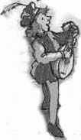
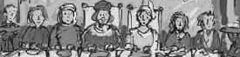
Now you can use some of your ideas and turn them into set of instructions for Sir Hugo.

Write instructions for what he should do for organising the food, OR organising the entertainment, OR organising the guests.

- Make sure that all your instructions are really needed, and don’t leave anything important out.
- The instructions need to be clear, so you don’t leave poor Sir Hugo guessing!
- Check that all of the steps are in the right order.
- Remember that Sir Hugo is your servant, so you are giving him commands.
- Remember to use lists, numbers, bullet points and anything else that will make your instructions easy for Sir Hugo to follow.

Sir Hugo’s List of things to do to organise the for the feast.

