
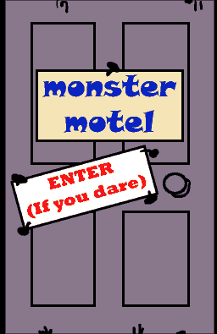

Name ……………………………………

Date ……………………………………..

Monster recipes

recipe

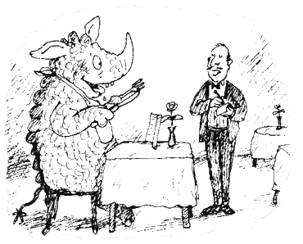
What’s on the menu at the Monster Motel? Look in the kitchen at: http://www.kidsonthenet.com/motel/motel/kitchen.html

Make up your own yucky monster recipe:

My recipe is for
On the menu I would describe it as

The ingredients are
and the steps to make it are

