
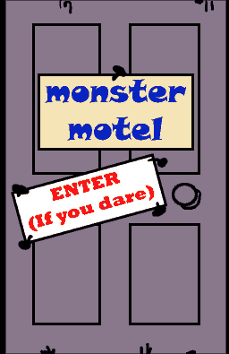

Name ……………………………………

Date ……………………………………..

Monsters2
Create a monster

Check out the Monster Motel, and look in the rooms if you dare, at http://www.kidsonthenet.com/motel
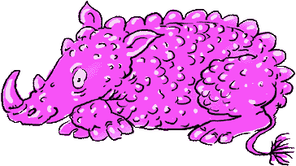

Make up your own monster:

My monster is
and has ……………………..arms and legs.
It sometimes hides and pretends to be…………………………………..
It likes to eat while.
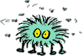
…………………………………………………………………………………………………………………………………………………..

My own ideas:

