
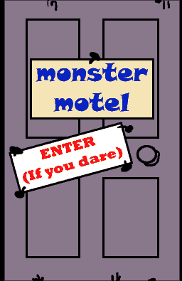

Name ……………………………………

Date ……………………………………..

Monsters portrait

Monster portrait

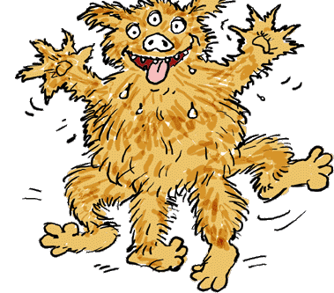
Check out the Monster Motel, and look in the rooms if you dare, at http://www.kidsonthenet.com/motel/motel/welcome.html

Describe this horrible guest:

In Room 19 there's a monster who has ....... legs and
......eyes. His head
is just like a ......... and he's the same colour as ..………………....... He's covered in ..... and wears ........... When I went past the door just now
he dashed out and gave me a big wet........

My own ideas:

