


Name ……………………………………

Date ……………………………………..

Researching Information

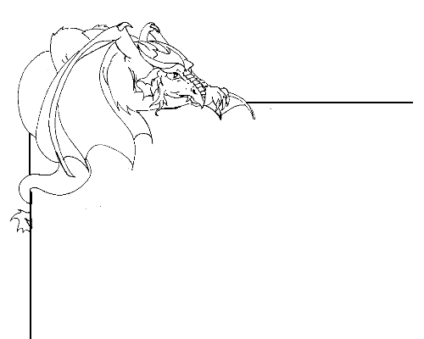

Research about dragons

Research writing involves looking through a range of materials that contain information that you might include in your research.
Understand what it is that you are being asked to write about. If you are not sure, ask your teacher or an adult to explain the task to you again.
Brainstorm on a sheet of paper what it is that you will be writing about. You might like to brainstorm with a friend, or alone.
Think about some key questions that you would like to find the answers to by the time you have completed the task. Write down the key questions.
Set yourself a time schedule for when you are going to work and rest. It is also a good idea to set yourself a completion date (a deadline) for the research. If you are doing this work in school your teacher may set a schedule for research time.
Begin to search for the information that you will need to refer to in your research. Use the index and glossaries in books, a web search, a list of useful websites, or your local or school library to find relevant materials.
Begin to make outline notes from the materials you have collected.
Focus in on your key questions and look for information that will help you to answer them. If you try to write about everything you have read about you will have too much information, and not enough detail.
Think about the audience for your work, and write a rough draft of your research;
- Begin with an outline of what you will be writing about and what you will be arguing for or against, or justifying.
- Include your research as the main part of your writing. Use the notes you made to answer the key questions in detail.
- Finally write a summary of what you set out to answer, and what you think the answers to your key questions are.

Look through your draft and begin to edit it;
  - Remove any irrelevant information that you have included
  - Check your grammar and punctuation
  - Ask a friend / teacher / adult to proof read it for you
Notes

Key Questions:___________________________________________________

___________________________________________________

___________________________________________________

Research Notes:

Publish your work, either on paper or electronically.

Your Report

Send your report to Dragonsville by typing it into the web form at
http://kotn.ntu.ac.uk/dragonsville/rockform.htm

