


Name ……………………………………

Date ……………………………………..

Writing to persuade

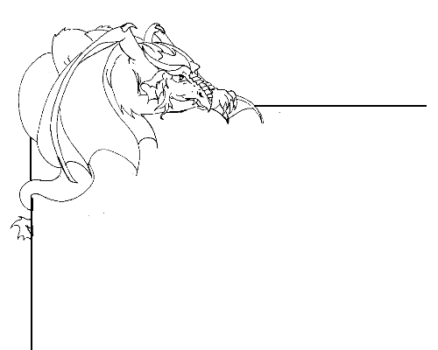

Writing a report

Persuasive writing is a way to argue for a particular point of view, and to attempt to convince the reader to that point of view.
Look at http://kotn.ntu.ac.uk/dragonsville/cavern.htm for examples of persuasive writing.
You are going to write a report in which you will try to persuade someone to your point of view.

What are you going to write about?

What are the key points that you want to try and persuade people about?

How are you going to begin your report? What will be your opening statement? For example “Dragons are not nasty animals” or “Are mythical creatures real?”

Start by stating your initial key point, and then begin to elaborate on it and justify your opinion.

Reiterate your key point(s) in the summary, and rewrite your opening statement to show that you have argued for your point of view e.g. “we have seen that”

…………………………………………………………………………………………………….

Remember to think about the following when you write your report;

- Write in the present tense.
- Use connective links like “however”, “this shows”, “therefore”, and “so” for example.
- Humour can help to persuade people to your point of view.
- State facts and good reasons, rather than suggestion or persuasive comments.
- Short sentences add emphasis to your argument.
- Using “Everyone agrees that”, “we all know that” will make the reader think that everyone else already agrees.
- Be friendly in your argument, avoid being harsh.
- Counter an argument that might be used in opposition to your point of view.
- A suitable image can have more effect than writing. Use images if appropriate.
- Read your report yourself – has it persuaded you? Rewrite parts if needed.

Send your report to Dragonsville by typing it into the web form at
http://kotn.ntu.ac.uk/dragonsville/discussform.htm

