


Name ……………………………………

Date ……………………………………..

Writing to persuade

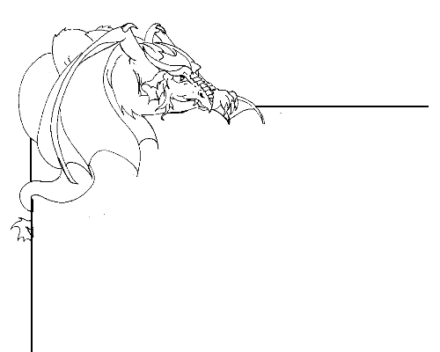

Creating a poster

Persuasive writing is a way to argue for a particular point of view, and to attempt to convince the reader to that point of view.
Look at http://kotn.ntu.ac.uk/dragonsville/cavern.htm for examples of persuasive writing. You are going to create a poster to persuade children to visit Dragonsville.

What are you going to put onto your poster? Will there be images? Writing?

What do you want to tell people about? The places around Dragonsville? The creatures?

Who is the poster going to be read by? Is the writing suitable for them?

How big does the poster need to be? Will it fit onto an A4 sheet, or a larger piece of paper?

How are you going to make the poster grab people’s attention?

Visit http://kotn.ntu.ac.uk/dragonsville/poster.htm and try the online flash based persuasive poster activity

…………………………………………………………………………………………………….

When designing your poster think about;
  - An attention-grabbing headline e.g. “Dare you enter Dragonsville?”
  - Eye catching images. These could be the creatures or places in Dragonsville.
  - Exaggerated claims like “Soar to the moon on the back of a dragon”.
  - Alliteration, e.g “dragons dancing delightfully” or “fountains of fiery flames”.
  - Basic information., such as how to get to Dragonsville, or what is there.
  - Endorsements from children, such as “I’ve never had so much fun”

Where are you going to put your headline, images, and additional information?
Will you put the title at the top of the page? At the bottom of the page? Vertical down the page? Will the image be put into the middle of the poster? At the top? At the bottom?

Persuasive Poster Activity

Send your poster to Dragonsville by scanning it and sending it to
kotn@ntu.ac.uk

