


Name ……………………………………

Date ……………………………………..

Writing Instructions

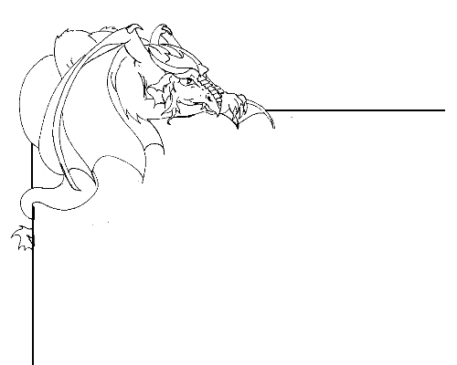

Writing a set of Instructions for the dragons

Instructional writing presents a task to the reader in such a way that they are able to follow a series of specific directions that result in the successful completion of the task. You are going to be asked to create a set of instructions to present to the dragons of Dragonsville. You can see examples of instruction writing at http://kotn.ntu.ac.uk/draognsville/instructions.htm

What is the task that you are going to provide instructions for?

Think about what is to be achieved at the end of the instructions - the goal.

Are there any materials that will be needed to be collected before the instructions can be followed? You will need to tell the reader about these before you begin the instructions.

Have you thought about the sequence that the instructions need to be written down in?

Who are you writing for? How will you make sure that they will be able to understand your instructions?

Are you going to include any pictures or diagrams? Will they help to make the instructions clearer?

…………………………………………………………………………………………………….

Once you have thought about these questions, then you can begin to write your instructions. Remember;

  - Your title should explain what the task is, for example “How to hide from knights”.
  - Do not use technical words that can confuse the reader.
  - Place your instructions in a chronological order. Use words like first, next, then, etc
  - Use numbers, or bullet points, for each step in the instructions.
  - Use verbs, but avoid adjectives, for example “Break the egg” not “Break the brown egg”
  - Try to use “you” throughout to make it friendly to the reader, e.g. “You will need to”
  - Keep the instructions short and to the point.

Instructions for
……………………………………………………………

Send your instructions to Dragonsville by typing it into the web form at
http://kotn.ntu.ac.uk/dragonsville/rockform.htm

