


Hyperlinked Activity

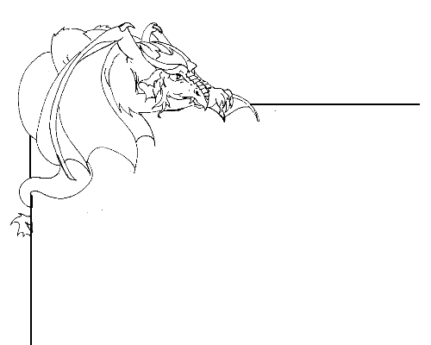

All about me

My Character Description;

Read the character descriptions of (put in name 1) or (put in name 2)

