


Name ……………………………………

Date ……………………………………..

Character Portraits

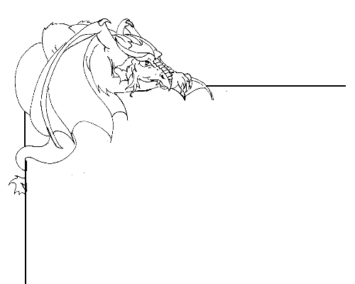

Write a character portrait for a dragon

A character portrait is a description of someone, and is used to describe the unique characteristics of that person.
You are going to be asked to write a character portrait for one of the dragons in the Naming Pool. See the dragons by going to http://kotn.ntu.ac.uk/dragonsville/pool.htm

Look through the dragons that are displayed on the Naming Pool web page.

Once you have chosen a dragon you need to think about what this dragon is like.
You could use the image to help with the description.

What does the dragon like to do? Does it have a favourite hobby or sport?

What type of mood is the dragon in most of the time? Why do you think that?

Is this a friendly dragon? What other words might you use to describe it?

…………………………………………………………………………………………………….

When writing your character description remember;

  - Begin your writing with “This is…..” then the name of the dragon.
  - Use the name of the dragon sometimes, and pronouns like he, she, hers, and his at other times.
  - Use the present tense rather than the past tense, i.e. “She likes to” instead of “She liked to”.
  - Begin new lines for each character feature that you write about.
  - Keep your sentences short and to the point. Avoid writing about irrelevant information.
  - Make use of descriptive language throughout your description.

A character portrait

Send your character portraits to Dragonsville by typing it into the web form at
http://kotn.ntu.ac.uk/dragonsville/name.htm

