


Name ……………………………………

Date ……………………………………..

Character Portraits

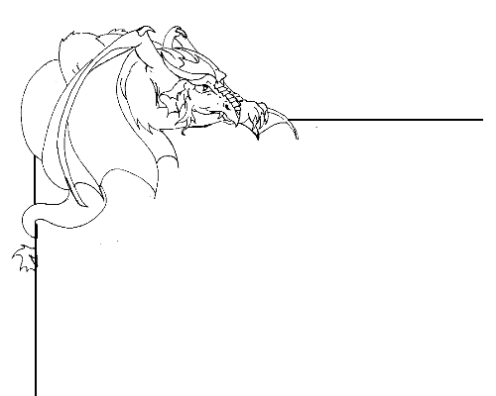

Designing a ‘Lost’ poster for a dragon

A character portrait is a description of someone, and is used to describe the unique characteristics of that person.
You are going to be asked to write a character portrait for one of the dragons in the Naming Pool. See the dragons by going to http://kotn.ntu.ac.uk/dragonsville/pool.htm

Look through the dragons that are displayed on the Naming Pool web page.

Chose a dragon from the gallery and ask your teacher if you can print out the image of the dragon for use in your poster.

What information would you include on the poster to help people find your ‘lost’ dragon? Will this help people to recognise your ‘lost’ dragon?

How will people contact you once they find your dragon? Are you going to put your name, or a (pretend) phone number, or (pretend) email address?

Are you going to give a reward for finding your dragon? What is this going to be? Will this be mentioned on the poster?

…………………………………………………………………………………………………

When designing your poster remember;

- Plan it out first. Sketch the idea out on a piece of scrap paper to get the design right.
- How is it going to catch people’s attention? Are you going to make it colourful?
- Could someone walking past read the poster quickly, or is there too much writing on it?
- Include keywords that describe your dragon’s characteristics, and avoid long sentences.
- Include the name of your ‘lost’ dragon once and then use pronouns.

Lost Poster

