


Name ……………………………………

Date ……………………………………..

Writing a biography

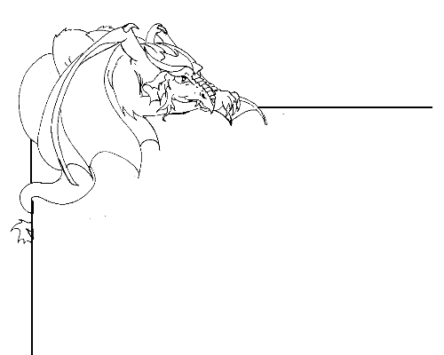

Write the biography of a dragon

A biography is a piece of writing that tells an account of a person's life. It is written, composed, or produced by another person.

Before you write a dragon biography look at the Dragonsville web page about the dragons (http://kotn.ntu.ac.uk/dragonsville/bioggallery.cfm). Read some of the other biographies. Look for additional information about dragons in books, CDRoms, or on the Internet. A list of useful sites is viewable (http://kotn.ntu.ac.uk/dragonsville/links.htm).

How old do you think the dragon is? How do you know this?

Who were the dragon’s parents? Where was it born? Is there any other information about its family that can be included in the biography?

Has the dragon been on any adventures? How did this make the dragon feel?

Does the dragon have any ‘battle wounds’? How did it get these?

Who has the dragon met before? What happened when they met?

What job did the dragon have in Dragonsville?

…………………………………………………………………………………………………….

Once you have thought about these questions you can begin to write a biography.

- Begin with an introduction about the dragon’s name, age and family.
- Write about any adventures or events that occurred, in a chronological order, beginning with the earliest adventures / events.
- Use a mixture of both the dragon’s name and pronouns, (he, she, hers, his, etc.).
- Use paragraphs throughout the biography.
- Try to make use of connectives (such as then, before) and conjunctions (such as but, when) to link together clauses into longer sentences.

The biography of ………………..

Send your biography to Dragonsville by typing it into the web form at
http://kotn.ntu.ac.uk/dragonsville/biog.htm

