
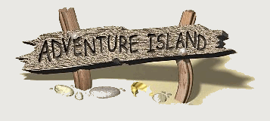

Name ……………………………………

Date ……………………………………..

Descriptive writing


Writing descriptively

Visit a completed island and read some of the descriptions of the locations. You are going to write a description for part of your group’s island. Ask your teacher for the coordinate you are describing. (Go to http://www.kidsonthenet.com/adventureisland)

How are you going to describe your location?

How will you begin? e.g. ‘you continue walking and …’, ‘you arrive at …’, ‘I continued to walk and …’, or ‘I came to …’

How will you complete the description? e.g ‘you can see paths leading …’, ‘ I carried on exploring …’

…………………………………………………………………………………………………….
Remember to think about:

- The coordinate that you are describing before you begin.
- Writing in either the first person if you are writing in the style of a dairy, or in the second person if you are guiding the reader around the island (your teacher will have explained how you are to write);
  - If you are writing in the first person use pronouns such as ‘I’, ‘we’, ‘my’, ‘our’, etc
  - If you are writing in the second person use pronouns like ‘you’.
- Using adjectives to describe nouns where it is appropriate, but avoiding using more than two adjectives together.
- Including similes or metaphors where appropriate, e.g. ‘the rocks look like jagged knives’, ‘the grass is a carpet’
- How your senses would react in the location;
  - What sounds can be heard around the location?
  - What can be seen around the location?
  - How do objects feel when they are touched?
  - What food is there, how does it taste?
  - What smells are noticeable?
And then describe these sensations to the reader.
- Using adverbs with your verbs to give the reader more information what an object is doing, eg. ‘A gentle breeze blows across the beach’, ‘the leaves fall slowly from above’, ‘the insects quiet buzzing is all around’

Coordinate being described: .
Name of island: .

