
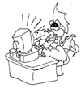

Name ……………………………………

Date ……………………………………..

Hyper linked Writing

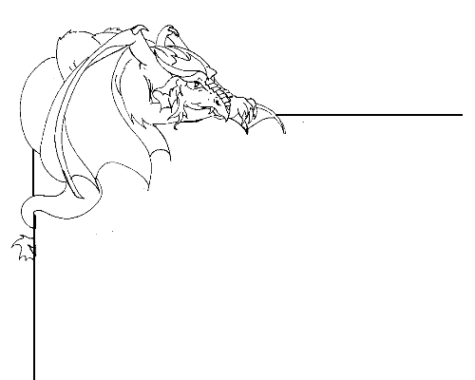

All about me

Hyper-linking is a way of making clickable links between different web pages, or different documents.
Hyperlinks are often underlined, and when a mouse is moved across them the pointer changes to a hand.

Write a short character portrait about yourself. You could visit the Naming Pool within Dragonsville (http://kotn.ntu.ac.uk/dragonsville/pool.htm) to see examples of character portraits.

Choose two other people within your class or group who are also writing their own character portrait and include their names within your character portrait.

Once you have written and edited your character portrait, load the document ‘hyperlinked_character_portrait.doc’ on a computer.

Type in your writing, and add the two othernames in the box where indicated.

Highlight the first name in the lower box by left clicking and dragging your mouse across the word.

Now click on the small globe with a chain in the icon in front of it that can be found on the grey toolbar at the top of the screen (if you leave your mouse over it for a moment it should say ‘Insert Hyperlink’)

In the long white box that appears, type in the name of the document that the named person has made. For example, if you are linking to a piece of writing by Susan, then type ‘susan-hyperlink.doc’ in the box. For James, type ‘james-hyperlink.doc’

Repeat this for the second name in your lower box.

Save your work using as ‘name-hyperlink.doc’, for example ‘paul-hyperlink.doc’

Once everyone has completed their own documents, they will all contain hyperlinks that will allow you to jump between different children’s character portraits making a class ‘web’.

Hyperlink activity
Character Portrait for

My work will be saved as hyperlink- .doc

First person to link to: ……………………………………………… Their work is called hyperlink- .doc

Second person to link to: ………………………………………… Their work is called hyperlink- .doc

